Features of Java
The primary objective of Java programming language creation was to make it portable, simple and secure programming language
A list of the most important features of the Java language is given below.
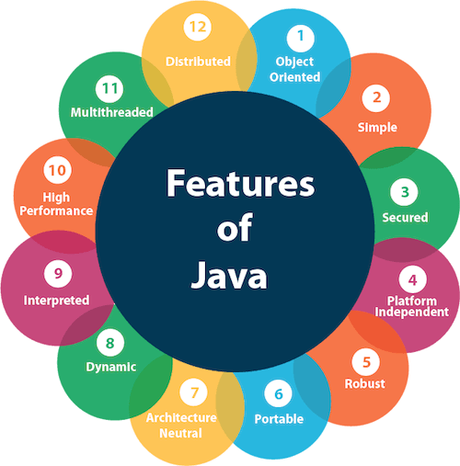
- Simple
- Object-Oriented
- Portable
- Platform independent
- Secured
- Robust
- High Performance
- Multithreaded
- Distributed
- Dynamic

Simple
Java is very easy to learn, and its syntax is simple, clean and easy to understand. According to Sun Microsystem, Java language is a simple programming language because:
- Java syntax is based on C++ (so easier for programmers to learn it after C++).
- Java has removed many complicated and rarely-used features, for example, explicit pointers, operator overloading, etc.
- There is no need to remove unreferenced objects because there is an Automatic Garbage Collection in Java.

Object-oriented
Java is an object-oriented programming language. Everything in Java is an object. Object-oriented means we organize our software as a combination of different types of objects that incorporate both data and behavior.
Object-oriented programming (OOPs) is a methodology that simplifies software development and maintenance by providing some rules.
Basic concepts of OOPs are:
- Object
- Class
- Inheritance
- Polymorphism
- Abstraction
- Encapsulation

Platform Independent
Java code can be executed on multiple platforms, for example, Windows, Linux, Sun Solaris, Mac/OS, etc. Java code is compiled by the compiler and converted into bytecode. This bytecode is a platform-independent code because it can be run on multiple platforms, i.e., Write Once and Run Anywhere (WORA).

Secured
Java is best known for its security. With Java, we can develop virus-free systems. Java is secured because:
- No explicit pointer
- Java Programs run inside a virtual machine sandbox
Java language provides these securities by default. Some security can also be provided by an application developer explicitly through SSL, JAAS, Cryptography, etc.

Robust
The English mining of Robust is strong. Java is robust because:
- It uses strong memory management.
- There is a lack of pointers that avoids security problems.
- Java provides automatic garbage collection which runs on the Java Virtual Machine to get rid of objects which are not being used by a Java application anymore.
- There are exception handling and the type checking mechanism in Java. All these points make Java robust.
Portable
Java is portable because it facilitates you to carry the Java bytecode to any platform. It doesn't require any implementation.

High-performance
Java is faster than other traditional interpreted programming languages because Java bytecode is "close" to native code. It is still a little bit slower than a compiled language (e.g., C++). Java is an interpreted language that is why it is slower than compiled languages, e.g., C, C++, etc.

Distributed
Java is distributed because it facilitates users to create distributed applications in Java. This feature of Java makes us able to access files by calling the methods from any machine on the internet.

Multi-threaded
A thread is like a separate program, executing concurrently. We can write Java programs that deal with many tasks at once by defining multiple threads. The main advantage of multi-threading is that it doesn't occupy memory for each thread. It shares a common memory area. Threads are important for multi-media, Web applications, etc.

Dynamic
Java is a dynamic language. It supports the dynamic loading of classes. It means classes are loaded on demand. It also supports functions from its native languages, i.e., C and C++.
Java supports dynamic compilation and automatic memory management (garbage collection).

C++ vs Java
There are many differences and similarities between the C++ programming language and Java. A list of top differences between C++ and Java are given below:
Comparison Index | C++ | Java
Platform-independent | C++ is platform-dependent. | Java is platform-independent.
Mainly used for | C++ is mainly used for system programming. | Java is mainly used for application programming. It is widely used in Windows-based, web-based, enterprise, and mobile applications.
Goto | C++ supports the goto statement. | Java doesn't support the goto statement.
Multiple inheritance | C++ supports multiple inheritance. | Java doesn't support multiple inheritance through class. It can be achieved by using interfaces in java.
Operator Overloading | C++ supports operator overloading. | Java doesn't support operator overloading.
Pointers | C++ supports pointers. You can write a pointer program in C++. | Java supports pointer internally. However, you can't write the pointer program in java. It means java has restricted pointer support in java.
Compiler and Interpreter | C++ uses compiler only. C++ is compiled and run using the compiler which converts source code into machine code so, C++ is platform dependent. | Java uses both compiler and interpreter. Java source code is converted into bytecode at compilation time. The interpreter executes this bytecode at runtime and produces output. Java is interpreted that is why it is platform-independent.
Call by Value and Call by reference | C++ supports both call by value and call by reference. | Java supports call by value only. There is no call by reference in java.
Structure and Union | C++ supports structures and unions. | Java doesn't support structures and unions.
Documentation comment | C++ doesn't support documentation comments. | Java supports documentation comment (/** ... */) to create documentation for java source code.
Virtual Keyword | C++ supports virtual keyword so that we can decide whether or not to override a function. | Java has no virtual keyword. We can override all non-static methods by default. In other words, non-static methods are virtual by default.
Hardware | C++ is nearer to hardware. | Java is not so interactive with hardware.
Object-oriented | C++ is an object-oriented language. However, in the C language, a single root hierarchy is not possible. | Java is also an object-oriented language. However, everything (except fundamental types) is an object in Java. It is a single root hierarchy as everything gets derived from java.lang.Object.

